UNIT IV
Pointers: Introduction, Pointers to pointers, Compatibility, L value and R value, Tips and Common Programming Errors, Key Terms, Summary, Practice Set.
Pointer Applications: Arrays, and Pointers, Pointer Arithmetic and Arrays, Memory Allocation Function, Array of Pointers, Programming Application, Tips and Common Programming Errors, Key Terms, Summary, Practice Set.
Processor Commands: Processor Commands, Tips and Common Programming Errors, Key Terms, Summary, Practice Set.
Pointers
Introduction
- A pointer is a constant or variable that contains an address that can be used to access data.
Pointer Constants
- A pointer constant is a value and can be stored in a variable. For example, it is having a character constant ‘G’ in it. The variable has an address in memory.
- The addresses within a computer cannot change, but the address of the variable can and will change from one run of our program to another.
- This is because operating systems can put a program in memory wherever it is convenient when the program is started.
Pointer Values
- If we have a pointer constant, we should be able to save its value with an address operator. The address operator (&) extracts the address for a variable.
- The addresses would also be different in different computers. However, most of the time, the computer allocates two adjacent memory locations because we defined the two variables one after the other.
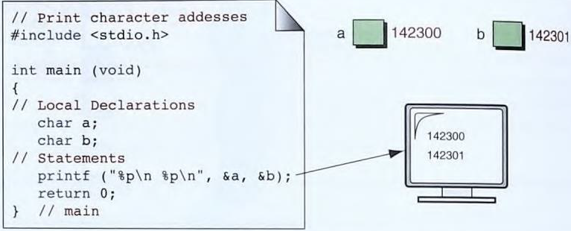
Pointer Variables
- We can store the address of a variable into another variable, which is called a pointer variable.
- In the below figure we see a variable, a, with its value, -123. The variable a is found at location 234560 in memory. It has a pointer variable, p. the variable’s name and location are constant, the value may change as the program executes.
- Its value at this point is the memory location 234560. This means that p is pointing to a.
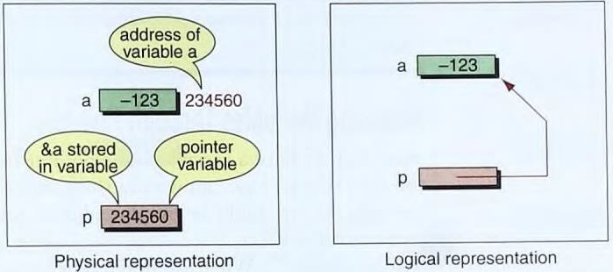
Accessing Variables through Pointers
- C has provided an operator (*). It is called indirection operator. To access the variable a through the pointer p, we simply code * p.
- For example, we need to add 1 to the variable a. We can do this with any of the following statements, assuming that the pointer, p, is properly initialized (p = & a).
a++; a = a + 1; *p = * p + 1; (*p) ++;
- & x, the address of x, * (& x), dereferences the pointer constant, giving the variable (x) itself.
Pointer Declaration and Definition
- We use the asterisk to declare pointer variables.
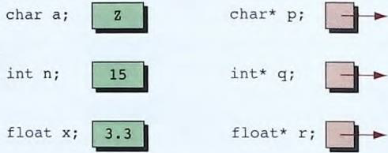
#include <stdio.h>
int main (void)
{
// Local Declarations
int a;
int* p;
// Statements p 135760
a = 14;
p = &a;
printf("%d %p\n", a , & a ) ;
printf( "%p % d % d \ n", p,*p, a ) ;
return 0;
}
Output:
14 00135760
00135760 14 14
Pointers to Pointers
- All pointers have been pointing directly to data. It is possible to use pointers that point to other pointers.
- For example, we can have a pointer pointing to a pointer to an integer. is no limit as to how many levels of indirection. But we limit ourselves to two.
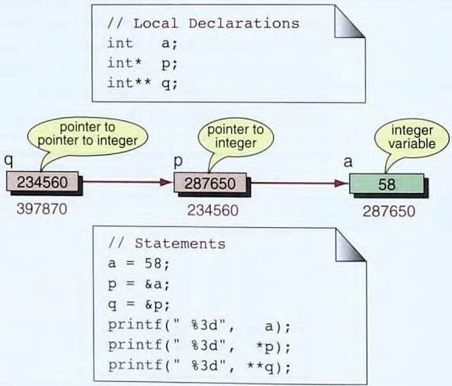
Compatibility
- It is important to recognize that pointers have a type associated with them.
- Each pointer therefore takes on the attributes of the type to which it refers in addition to its own attributes.
Pointer Size Compatibility
- The size of all pointers is the same. Every pointer variable holds the address of one memory location in the computer.
- The size of the variable that the pointer references can be different; it takes the attributes of the type being referenced.
#include <stdio.h>
int main (void)
{
char c;
char* pc;
int sizeofc = sizeof(c);
int sizeofpc = sizeof(pc);
int sizeofStarpc = sizeof(*pc);
int a;
int* pa;
int sizeofa = sizeof(a);
int sizeofpa = sizeof(pa);
int sizeofStarpa = sizeof(*pa);
double x;
double* px;
int sizeofx= sizeof(x);
int sizeofpx = sizeof(px);
int sizeofStarpx = sizeof(*px);
printf("sizeof(c): %3d", sizeofc);
printf("sizeof(pc): %3d|", sizeofpc);
printf("sizeof(*pc): %3e|”, sizeofStarpc);
printf("sizeof(a): %3d|", sizeofa);
printf("sizeof(pa): %3d|", sizeofpa);
printf("sizeof(*pa):%3d\n", sizeofStarpa);
printf( " sizeof(x): %3d | " , sizeofx );
printf("sizeof(px): %3d | " , sizeofpx);
printf("sizeof(*px ): %3d \n " , sizeofStarpx );
return 0;
}
Output:
sizeof(c): 1 sizeof(pc): 4|sizeof(*pc): 1
sizeof(a): 4 sizeof(pa ): 4 | sizeof( *pa): 4
sizeof(x): 8 | sizeof(px ): 4 | sizeof( *px): 8
Dereference Type Compatibility
- The dereference type is the type of the variable that the pointer is referencing.
- It is invalid to assign a pointer of one type to a pointer of another type, even though the values in both cases are memory addresses and would therefore fully compatible.
- In C, we can’t use the assignment operator with pointers to different types
- A pointer to a char is only compatible with a pointer to a char; and a pointer to an int is only compatible with a pointer to an int. We cannot assign a pointer to a char to a pointer to an int.
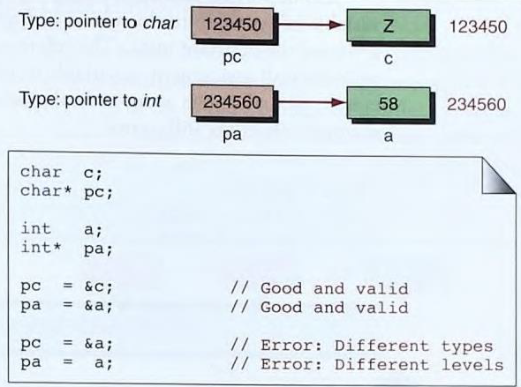
Pointer to Void
- A pointer to void is a type that is not associated with a reference type; that is, it is not the address of a character, an integer, a real, or any other type.
void * pVoid;
- null pointer and a variable of type pointer to void both are different.
- A null pointer is a pointer of any type that is assigned the constant NULL. The reference type of the pointer will not change with the null assignment.
- A variable of pointer to void is a pointer with no reference type that can store only the address of any variable.
void* pVoid; // Pointer to void type
int* pint = NULL; // Null pointer of type int
char* pChar = NULL; // Null pointer of type char
Casting Pointers
- The problem of type incompatibility can be solved if we use casting. We can make an explicit assignment between incompatible pointer types by using a cast, just as we can cast an int to a char.
pc = (char*) &a;
Dereference Level Compatibility
- Compatibility also includes dereference level compatibility. For example, a pointer to int is not compatible with a pointer-to-pointer to int.
- The pointer to int has a reference type ol int, while a pointer-to-pointer to int has a reference type of pointer to int.
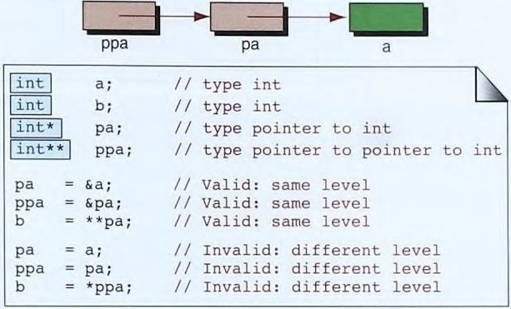
Lvalue and Rvalue
- In C, an expression is either an lvalue or an rvalue.
- Every expression has a value. But the value in an expression (after evaluation) can he used in two different ways.
- An lvalue expression must he used whenever the object is receiving a value; that is, it is being modified.
- An rvalue expression can be used to supply a value for further use; that is, to examine or copy its value.
- Only seven types of expressions are lvalue expressions
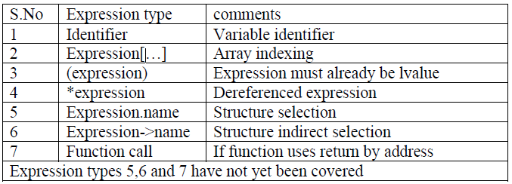
Example
a = ... a [ 5 ] = ... ( a ) = ... * p = ...
- The following show some rvalue expressions:
5 a + 2 a * 6 a [ 2 ] + 3 a + +
- if an expression is an lvalue, if it is used as part of a larger expression in which the operators create only rvalue expressions, then the whole expression is an rvalue.
- For example, a [ 2 ] is an lvalue. But when it is used in the expression a [ 2 ] + 3, the whole expression is an rvalue, not an lvalue. Similarly, in the expression a ++, the variable a is an lvalue while the whole expression ( a + + ) is an rvalue.
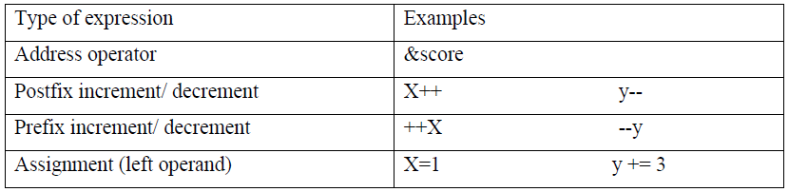
- Several examples of invalid expressions that will create syntax errors because an rvalue is used when an lvalue is needed.
  - 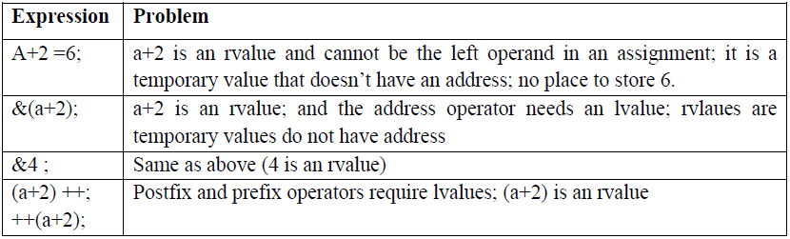
Pointer Applications
Arrays and Pointers
- The name of an array is a pointer constant to the first element. Because the array’s name is a pointer constant, its value cannot be changed.
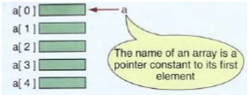
- The array name is a pointer constant to the first element, the address of the first element and the name of the array both represent the same location in memory.
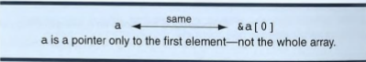
- We can print the value in the first element of the array using both a pointer and an index. Note that the same value, 2, is printed in both cases, that the array name is a pointer constant to the beginning of the array.
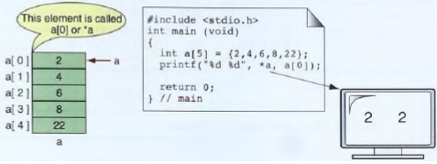
- If the name of an array is really a pointer we can store this pointer in a pointer variable and use it in the same way we use the name of the array.
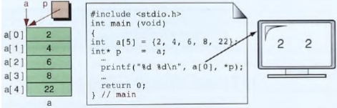
- Another example that explores the close relationship between an array and a pointer. We store the address of the second element of the array in a pointer variable.so we can use two different names to access each element
- This does not mean that we have two arrays; rather. It shows that a single array can be accessed through different pointers.
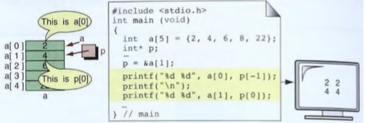
Pointer Arithmetic and Arrays
- Pointer arithmetic offers a restricted set of arithmetic operators for manipulating the addresses in pointers.
Pointers and One- Dimensional Arrays
- If we have an array, a, then a is a constant pointing to the first element and a + 1 is a constant pointing to the second element.
- If we have a pointer, p, pointing to the second element of an array then P - 1 is a pointer to the previous ( first) element and p + 1 is a pointer to the next (third) element.
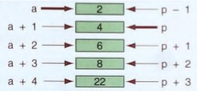
Arithmetic Operations on Pointers
- Addition can be used when one operand is a pointer and the other is an integer.
- Subtraction can he used only when both operands are pointers or when the first operand is a pointer and the second operand is an index integer.
- We can also manipulate a pointer with the postfix and unary increment and decrement operators.
Example: p + 5 5 + p P - 5 pl - p2 p++ —p
- The relational operators (such as less than and equal) are allowed only if both operands are pointers of the same type.
Example: pi >= p2 p1 != P2
Using Pointer Arithmetic
- Program we print the array elements in the forward and reverse direction using pointers.
#define MAX SIZE 10
int main()
{
int ary[ ] = {1 , 2, 3, 4, 5 , 6, 7, 8 , 9, 10};
int * pItr, * pEnd;
pEnd = ary + MAX _SIZE;
printf( " Array forward : ");
for ( pItr = ary ; pItr < pEnd ; pItr ++ )
printf ( "%3d ", * pWalk );
printf ("\n");
// Print array backward
printf ( "Array backward: " );
for ( pItr = pEnd - 1; pItr >= ary ; pItr ) - )
printf ( " %3d", *pWalk );
printf ( " \n");
return 0;
}
Results:
Array forward: 1 2 3 4 5 6 7 8 9 10
Array backward: 10 9 8 7 6 5 4 3 2 1
Pointers and Two-Dimensional Arrays
- A multidimensional is form of a[i][j]. It is a generalized form using pointer with multidimensional arrays.
*(*(ptr+i)+j) is same as a a[i][j]
- If we have a two-dimensional array of integers, when we dereference the array name, we don’t get one integer, we get an array of integers.
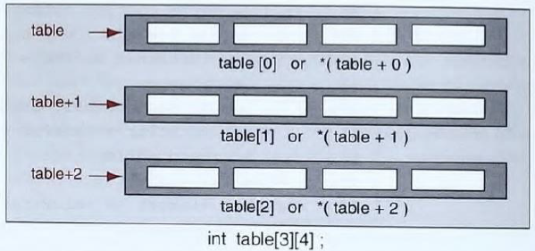
for (i = 0; i < 3; i++)
{
for (j = 0; j < 4; j++)
printf("%6d", *( *(table + i) + j));
printf( "\n" );
}
Memory Allocation Functions
- C provides us two ways to reserve memory locations for an object:
  - static allocation
  - dynamic allocation.
- Memory is divided into program memory and data memory.
- Program memory consists of the memory used for main and all called functions.
- Data memory consists of permanent definitions, such as global data and constants, local declarations, and dynamic data memory.
Block Memory Allocation (malloc)
- The malloc function allocates a block of memory that contains the number of bytes specified in its parameter and return a pointer of type void.
Syntax: Pointer=(cast type*)malloc(byte-size);
ptr= (void*)malloc(n*sizeof(int));
Here ptr is pointer of cast type.
Ex: ptr=(int *)malloc(byte-size);y
- On succes, it returns the base address of memory block.
- On failure, it returns null pointer.

Contiguous Memory Allocation (calloc)
- The memory allocation function, calloc, is primarily used to allocate memory for arrays.
- It differs from malloc only in that it sets memory to null characters.
Syntax: Pointer=(cast type*)calloc(n,element-size);
ptr= (void*)calloc(size n, element-size);
Ex: ptr=(int *)calloc(n,sizeof(int));
Where n = size of array
sizeof(int) = size of each element
- The result is the same for both malloc and calloc when overflow occurs and when a zero size is given.
Reallocation of Memory (realloc)
- The realloc function used When given a pointer to a previously allocated block of memory, realloc changes the size of the block by deleting or extending the memory at the end of the block.
- If the memory cannot be extended because of other allocations, realloc allocates a completely new block, copies the existing memory allocation to the new allocation, and deletes the old allocation.
void* realloc (void* ptr, size_t newSize);
Releasing Memory (free)
- When memory locations allocated by malloc, calloc, or realloc arc no longer needed, they should be freed using the predefined function free.
void free (void* ptr );
- Releasing memory does not change the value in a pointer. It still contains the address in the heap. So, after free the memory we can clear the pointer by setting it to NULL.
#include <stdio.h>
#include <string.h>
#include <stdlib.h>
main() {
char *ptr;
ptr = malloc(20); //or ptr = calloc(20,sizeof(char));
strcpy(ptr," Problem solving ");
printf("ptr : %s\n",ptr);
ptr = realloc( ptr,100);
strcpy(ptr," Programming for problem solving");
printf("ptr : %s\n",ptr);
free(ptr);
}
OUTPUT:
ptr : Problem solving
ptr : Programming for problem solving
Array of Pointers
- This structure is useful when the number of elements in the array is variable.
- The following table is an example of array of pointers.
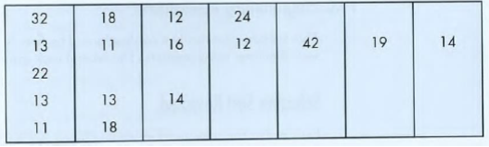
- It is a two-dimensional array in which only one row (1) is full. The rest of the rows contain from one to four elements. This array is also known as a ragged array because the right elements in each row may be empty.
- If we use a two-dimensional array for storing these numbers, we are wasting a lot of memory. The solution in this case is to create five one-dimensional arrays that are joined through an array of pointers.
int** table;
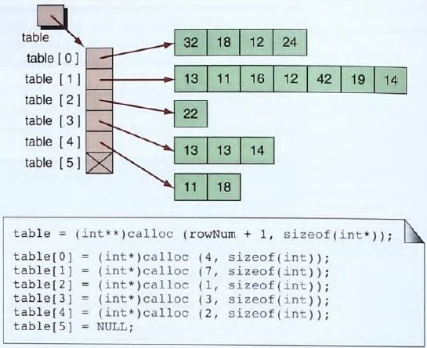
Programming Applications
- There are two applications
  - Rewrite of the selection sort using pointer.
  - Dynamic array
Selection sort revisited
- Selection sort starts by computing first two elements of an array and swapping is necessary if we want to sort the elements of an array in descending order.
- If the first element is less than the second element we need to swap the element, but if first element is greater than the second element we leave the element as it is.
- The again first and third element are compared and swapping if necessary.
- This process goes on until first and last element are compared.
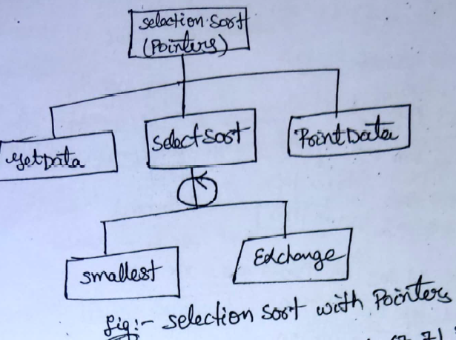
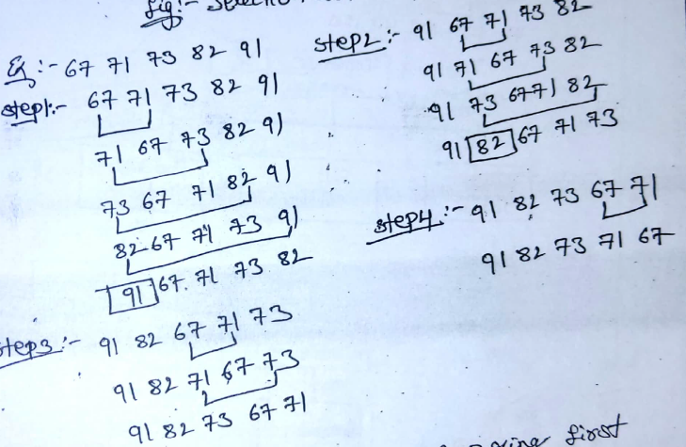
Dynamic array
- Dynamic array starts by comparing first two elelmets of array and swaps if it is necessary.
- This program creates a dynmaic table that can store a ragged array.
- The column and width of the dynamic array are tailored to the needs of the user using calloc.
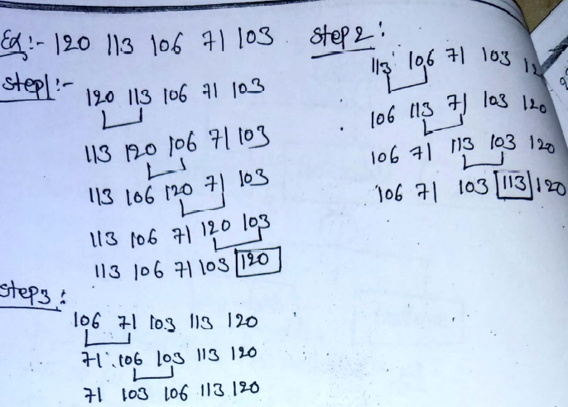
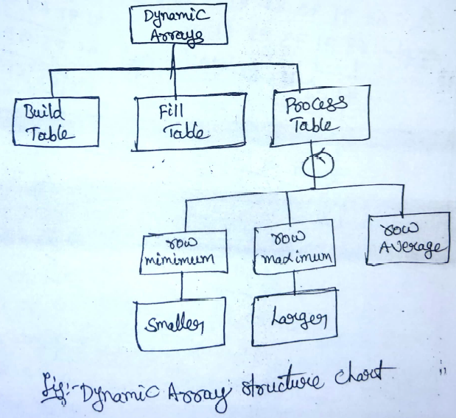
Processor Commands
Processor Commands
- The C compiler is made of two functional parts: a pre-processor and a translator.
- The pre-processor uses programmer-supplied commands to prepare the program for compilation.
- All preprocessor commands starts with pound (#) symbol.
- The translator converts the C statements into machine code.
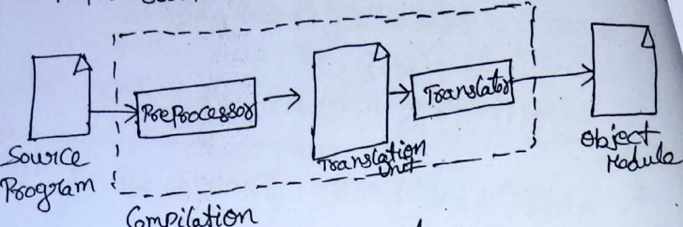
Compiler components
- The C preprocessor is a program that processes any source program in C before compilation. It allows the user to define macros, the C preprocessor is also called as a macro processor.
- A macro is defined as an open-ended subroutine, it is a set of program instructions, like in a function, that does not have a return statement.
- The preprocessor provides instructions to the preprocessor and are called directives.
- A directive usually occupies a single line. The #symbol should be the first character for every directive. If the length of the directive is more than one line then we have to use the character \(back slash).
- Directives are generally placed at the beginning of a source program, which means that these are written before the main ().
The C Preprocessor Directives
- The preprocessor directives are classified into two categories:
  - Unconditional
  - Conditional.
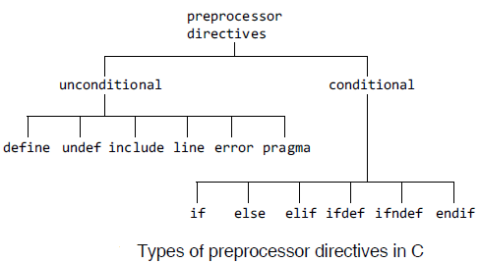
- The following are the C preprocessor directives with brief explanations.
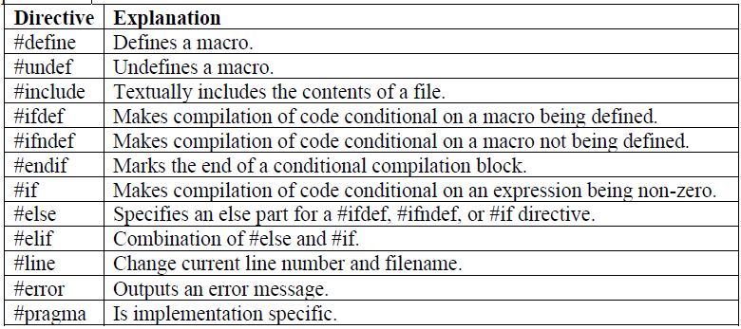
# define
- The general form is #define macro_name replacement_string
- The #define directive is used to make substitutions throughout the program in which it is located.
- No semicolon is used at the end of the directive.
#include <stdio.h>
#define TRUE 1
#define FALSE 0
int main()
{
int done=0;
if(TRUE)
printf(“\n Now done is TRUE”);
return 0;
}
Output
Now done is TRUE
- Another feature of the #define directive is that it can take arguments.
#include <stdio.h>
#define abs_value(a)((a<0)? –a : a)
int main()
{
int a=-1;
while(abs_value(a))
{
printf(“\n Value of a=%d within while”,a);
a=0;
}
printf(“\n Value of a=%d outside while”,a);
return 0;
}
Output
Value of a=-1 within while
Value of a=0 outside while
#undef
- The general form is
#undef macro_name
- A macro must be undefined before being redefined to a different value.
Example #define VALUE 1024
#undef VALUE
#define VALUE 22
#include
- The #include directive has two general forms
#include <file_name>
and
#include “file_name”
- The first form is used for referring to the standard system header files. It searches for a file named file_name in a standard header file library and inserts it at the current location.
- The angle brackets, < >, indicates the preprocessor to search for the header file in the standard location for library definitions.
- The second form searches for a file in the current directory. Here, code with the file_name can be put into the current directory and included in each program file.
- Local header file names are usually enclosed by double quotes, “ ”. Header files name should ends as ‘.h’ to distinguish them from other types of files.
#error
- It is used for reporting errors by the preprocessor.
#error error_message
- When the preprocessor encounters this, it outputs the error_message and causes the compilation to be aborted.
Example 1: #ifndef LINUX
#error This software requires the LINUX OS.
#endif
Example 2: #if A_SIZE < B_SIZE
#error “Incompatible sizes”
#endif
#line
- The #line directive is used to change the value of the __LINE__ and __FILE__ variables.
- The __FILE__ and the __LINE__ variables represent the current file and the line that is being read.
#line line_number <file _name>
Example: #line 20 “program1.c”
- It changes the current line number to 20, and the current file to “program1.c”.
#if, #else, #elif, and #endif
- #if is a conditional directive of the preprocessor. It has an expression that evaluates to an integer. #else is also used with #if this directive if required.
- The #if and #else pair operates in a way similar to the if-else construct of C.
- #endif is used to delimit the end of statement following the statement sequence.
#if< constant_expression>
<statement_sequence1>
#endif
(or)
#if< constant_expression>
<statement_sequence1>
#else<statement_sequence2>
#endif
#include <stdio.h>
#define VAX 1
#define SUN 0
int main()
{
#ifdef VAX
printf(“This is a VAX\n”);
#endif
#ifdef SUN
printf(“This is a SUN\n”);
#endif
return 0;
}
Output
This is a VAX
Predefined Macros
- The preprocessor has a small set of predefined macros that denote useful information.
- The standard macros are
Identifiers | Denotes
_FILE_ | Name of the file being processed
_LINE_ | Current line number of the file being processed
_DATE_ | Current date as string (e.g.,”16 Dec 2019”)
_TIME_ | Current time as string(e.g.,”10:15:30”)
- All predefined macros have two underscore characters more at the beginning and the other at the end.
#include <stdio.h>
int main()
{
printf(“__DATE__ == %s\n”,__DATE__);
printf(“__FILE__ == %s\n”,__FILE__);
printf(“__LINE__ == %d\n”,__LINE__);
printf(“__TIME__ == %s\n”,__TIME__);
printf(“__STDC__ == %d\n”,__STDC__);
return 0;
}
Output
__DATE__ == Dec 18 2010
__FILE__ == pred.c
__LINE__ == 11
__TIME__ == 17:25:09
__STDC__ == 1

